**熟悉PL/SQL语言**

1. **实验项目名称**

熟悉PL/SQL语言

**二、实验目的**

本实验为设计性实验。通过设计PL/SQL程序，帮助学生掌握PL/SQL语言的程序结构和流程控制语句，加强学生使用PL/SQL语言进行编程的能力。

**三、实验环境**

Windows8.1 + Oracle 11g。

**四、实验内容**

以user_<本人学号>登陆数据库，编写两段PL/SQL块，分别要求实现下列算法，将源程序和运行结果写入实验报告：

1.输出1~200之间的所有的素数；

2.求1!+2!+3!+…+10!的和。

**五、实验步骤**

1.在sqlplus中创建存储过程，再赋值200，输出1-200中的所有素数。

2.在sqlplus中执行pl/sql语句。

**六、源程序清单、测试数据、结果。**

1. 输出1~200之间的所有的素数；

set serverout on  
create or replace procedure is_prime(inp number)   
as  
 i number;  
 j number;  
 is_prim boolean;  
begin  
 dbms_output.new_line;  
 dbms_output.put(to_char(2)||' ');  
 [for](https://www.baidu.com/s?wd=for&tn=44039180_cpr&fenlei=mv6quAkxTZn0IZRqIHckPjm4nH00T1YzmvRvrjRYuHR1rjc1uAcs0ZwV5Hcvrjm3rH6sPfKWUMw85HfYnjn4nH6sgvPsT6KdThsqpZwYTjCEQLGCpyw9Uz4Bmy-bIi4WUvYETgN-TLwGUv3EnWD1P16vrHcLnjDLnWRznjfzr0) i in 3..inp

loop  
begin  
 is_prim:=true;  
 [for](https://www.baidu.com/s?wd=for&tn=44039180_cpr&fenlei=mv6quAkxTZn0IZRqIHckPjm4nH00T1YzmvRvrjRYuHR1rjc1uAcs0ZwV5Hcvrjm3rH6sPfKWUMw85HfYnjn4nH6sgvPsT6KdThsqpZwYTjCEQLGCpyw9Uz4Bmy-bIi4WUvYETgN-TLwGUv3EnWD1P16vrHcLnjDLnWRznjfzr0) j in 2..[trunc](https://www.baidu.com/s?wd=trunc&tn=44039180_cpr&fenlei=mv6quAkxTZn0IZRqIHckPjm4nH00T1YzmvRvrjRYuHR1rjc1uAcs0ZwV5Hcvrjm3rH6sPfKWUMw85HfYnjn4nH6sgvPsT6KdThsqpZwYTjCEQLGCpyw9Uz4Bmy-bIi4WUvYETgN-TLwGUv3EnWD1P16vrHcLnjDLnWRznjfzr0)(sqrt(i))

loop  
 [if](https://www.baidu.com/s?wd=if&tn=44039180_cpr&fenlei=mv6quAkxTZn0IZRqIHckPjm4nH00T1YzmvRvrjRYuHR1rjc1uAcs0ZwV5Hcvrjm3rH6sPfKWUMw85HfYnjn4nH6sgvPsT6KdThsqpZwYTjCEQLGCpyw9Uz4Bmy-bIi4WUvYETgN-TLwGUv3EnWD1P16vrHcLnjDLnWRznjfzr0) mod(i,j)=0 then   
 begin  
 is_prim:=false;  
 [exit](https://www.baidu.com/s?wd=exit&tn=44039180_cpr&fenlei=mv6quAkxTZn0IZRqIHckPjm4nH00T1YzmvRvrjRYuHR1rjc1uAcs0ZwV5Hcvrjm3rH6sPfKWUMw85HfYnjn4nH6sgvPsT6KdThsqpZwYTjCEQLGCpyw9Uz4Bmy-bIi4WUvYETgN-TLwGUv3EnWD1P16vrHcLnjDLnWRznjfzr0);   
 [end](https://www.baidu.com/s?wd=end&tn=44039180_cpr&fenlei=mv6quAkxTZn0IZRqIHckPjm4nH00T1YzmvRvrjRYuHR1rjc1uAcs0ZwV5Hcvrjm3rH6sPfKWUMw85HfYnjn4nH6sgvPsT6KdThsqpZwYTjCEQLGCpyw9Uz4Bmy-bIi4WUvYETgN-TLwGUv3EnWD1P16vrHcLnjDLnWRznjfzr0);  
 [end](https://www.baidu.com/s?wd=end&tn=44039180_cpr&fenlei=mv6quAkxTZn0IZRqIHckPjm4nH00T1YzmvRvrjRYuHR1rjc1uAcs0ZwV5Hcvrjm3rH6sPfKWUMw85HfYnjn4nH6sgvPsT6KdThsqpZwYTjCEQLGCpyw9Uz4Bmy-bIi4WUvYETgN-TLwGUv3EnWD1P16vrHcLnjDLnWRznjfzr0) [if](https://www.baidu.com/s?wd=if&tn=44039180_cpr&fenlei=mv6quAkxTZn0IZRqIHckPjm4nH00T1YzmvRvrjRYuHR1rjc1uAcs0ZwV5Hcvrjm3rH6sPfKWUMw85HfYnjn4nH6sgvPsT6KdThsqpZwYTjCEQLGCpyw9Uz4Bmy-bIi4WUvYETgN-TLwGUv3EnWD1P16vrHcLnjDLnWRznjfzr0);  
 [end](https://www.baidu.com/s?wd=end&tn=44039180_cpr&fenlei=mv6quAkxTZn0IZRqIHckPjm4nH00T1YzmvRvrjRYuHR1rjc1uAcs0ZwV5Hcvrjm3rH6sPfKWUMw85HfYnjn4nH6sgvPsT6KdThsqpZwYTjCEQLGCpyw9Uz4Bmy-bIi4WUvYETgN-TLwGUv3EnWD1P16vrHcLnjDLnWRznjfzr0) loop;  
 [if](https://www.baidu.com/s?wd=if&tn=44039180_cpr&fenlei=mv6quAkxTZn0IZRqIHckPjm4nH00T1YzmvRvrjRYuHR1rjc1uAcs0ZwV5Hcvrjm3rH6sPfKWUMw85HfYnjn4nH6sgvPsT6KdThsqpZwYTjCEQLGCpyw9Uz4Bmy-bIi4WUvYETgN-TLwGUv3EnWD1P16vrHcLnjDLnWRznjfzr0) is_prim then dbms_output.put(to_char(i)||' ');

end if;  
end;  
end loop;  
dbms_output.new_line;  
end;  
/  
exec is_prime(200)

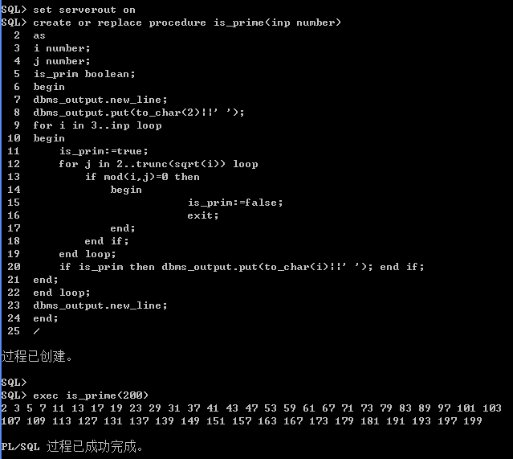

2. 在sqlplus中执行pl/sql语句。

SET SERVEROUTPUT ON

declare

num int:=0;

j int;

begin

for k in 1..10

loop

j:=1;

for i in 1..k

loop

j:=j*i;

end loop;

num:=num+j;

end loop;

dbms_output.put_line(num);

end;

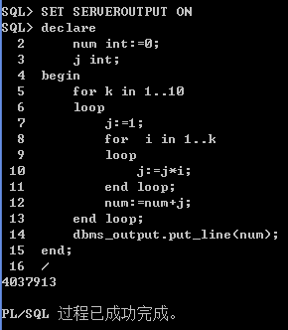

**七、实验小结和思考**

了解到了sqlplus建立过程和利用pl/sql编写小程序的方法。其中，要声明set serveroutput on才可以用dbms_output.put_line()函数。